**Name : divya shivajirao tikore**

**Rollno. 300167**

**Exercise No.: 01**

WAP to implement Towers of Hanoi using recursion.

Problem: There are 3 Towers ‘X’, ‘Y‘ and ‘Z’. Some disks of different sizes are given which can

slide onto any Tower. Initially all of those are in ‘X’ Tower in order of size with largest disk at the

bottom and smallest disk at the top. We have to move all the disks from ‘X’ Tower to ‘Z’ Tower.

At the end, ’Z’ Tower will have disks in the same order of size. There are some rules: 1) Only one

disk can be moved from one Tower to another Tower at a time. 2) A disk can be placed only on

top of a larger one. 3) A disk can be moved from top only.

Algorithm:

Towers of Hanoi Algorithm TOH(n, x, y, z)

{

If (n >= 1) then TOH (n-1, x, z, y);

Write(“move top disk from tower”, x , ”to top of tower”, y);

TOH(n-1,z, y, x);

}

For n=3, total 7 steps are required to transfer the disks from tower 1 to 3.

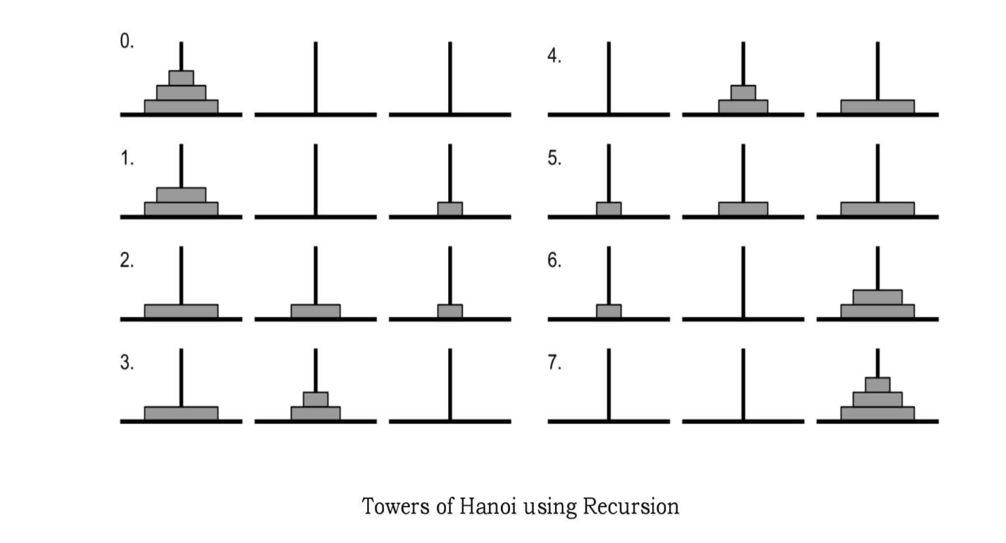

* Program (Handwritten code)

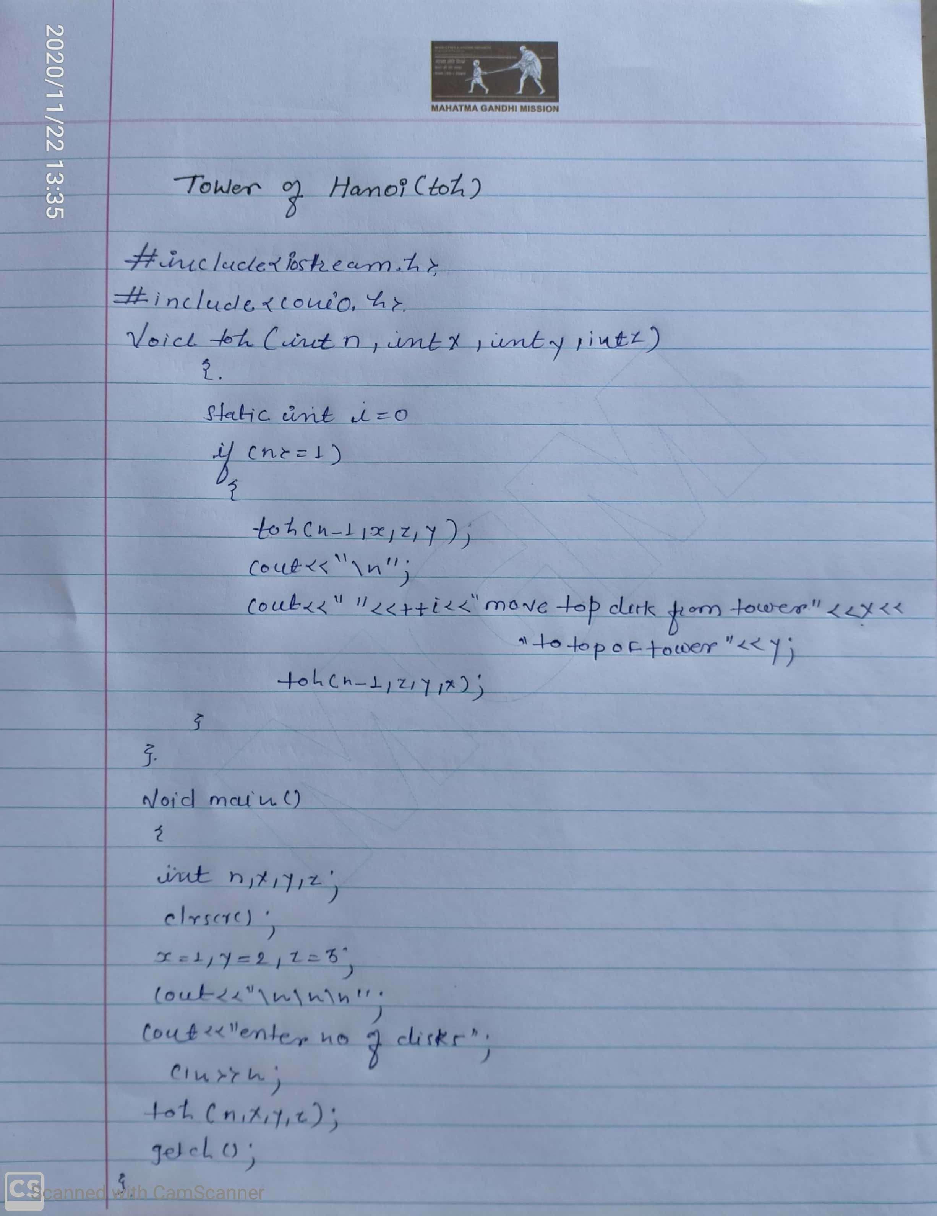

Screenshot of output

Conclusion

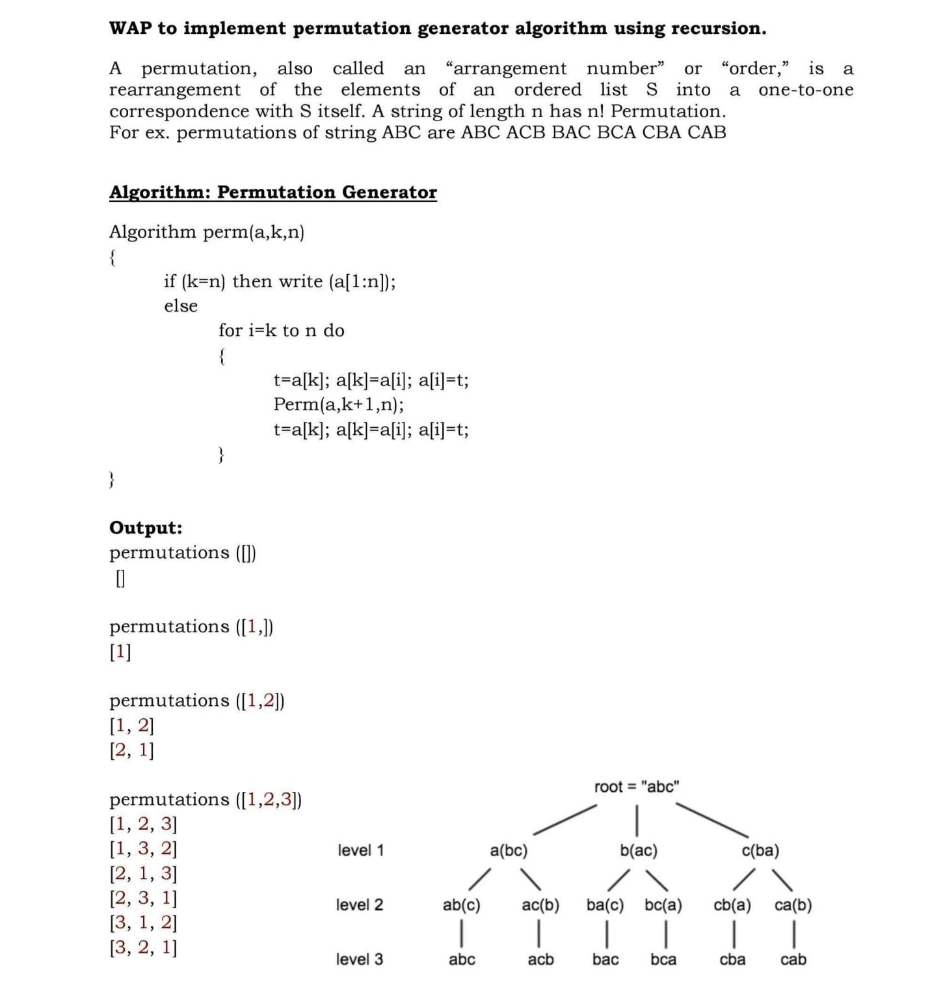 **Exercise No.: 02**

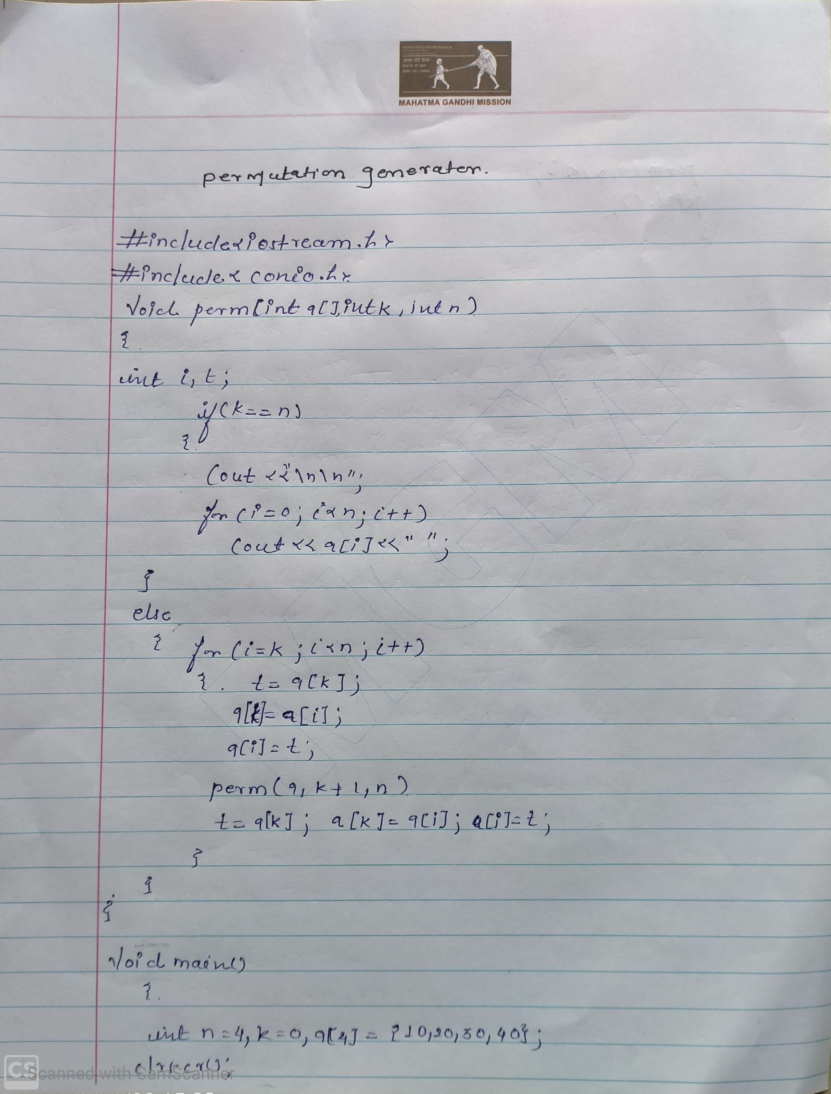

Screenshot of output

Conclusion

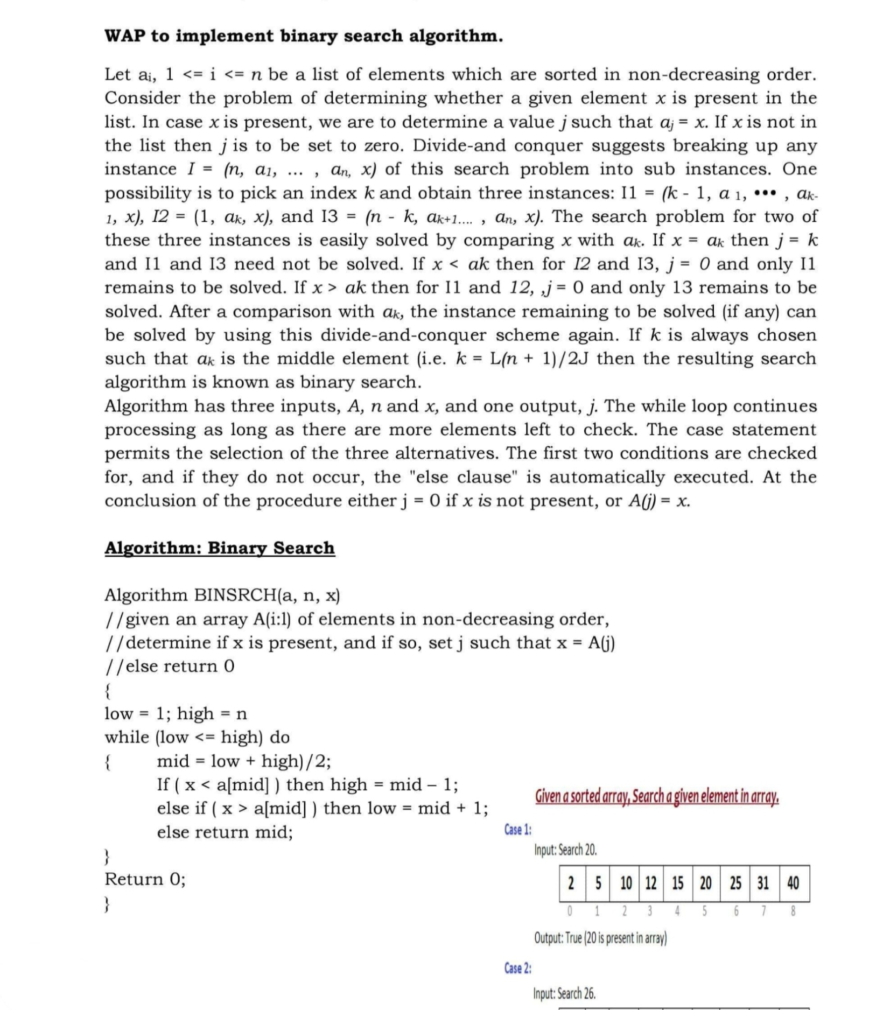 **Exercise No.: 0**3

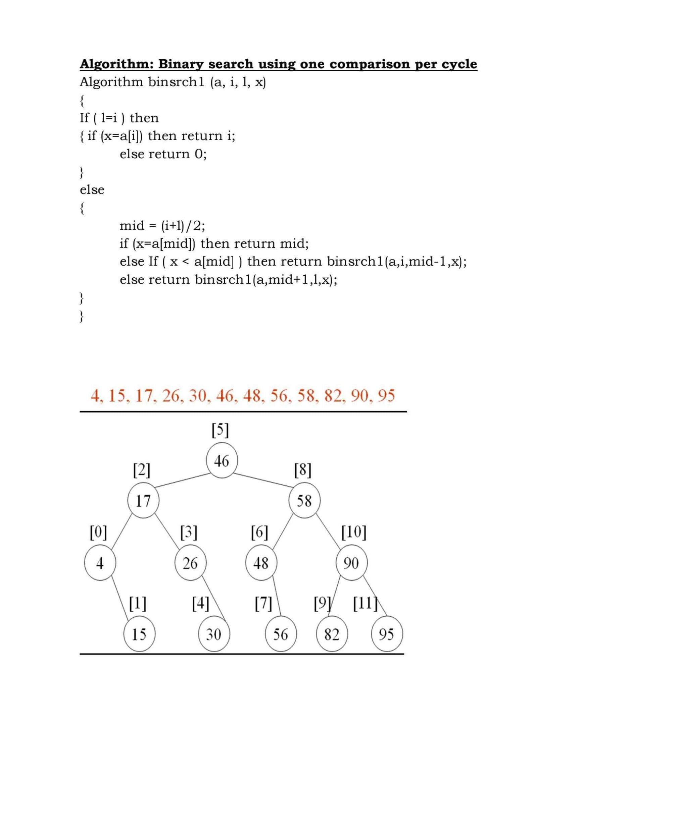

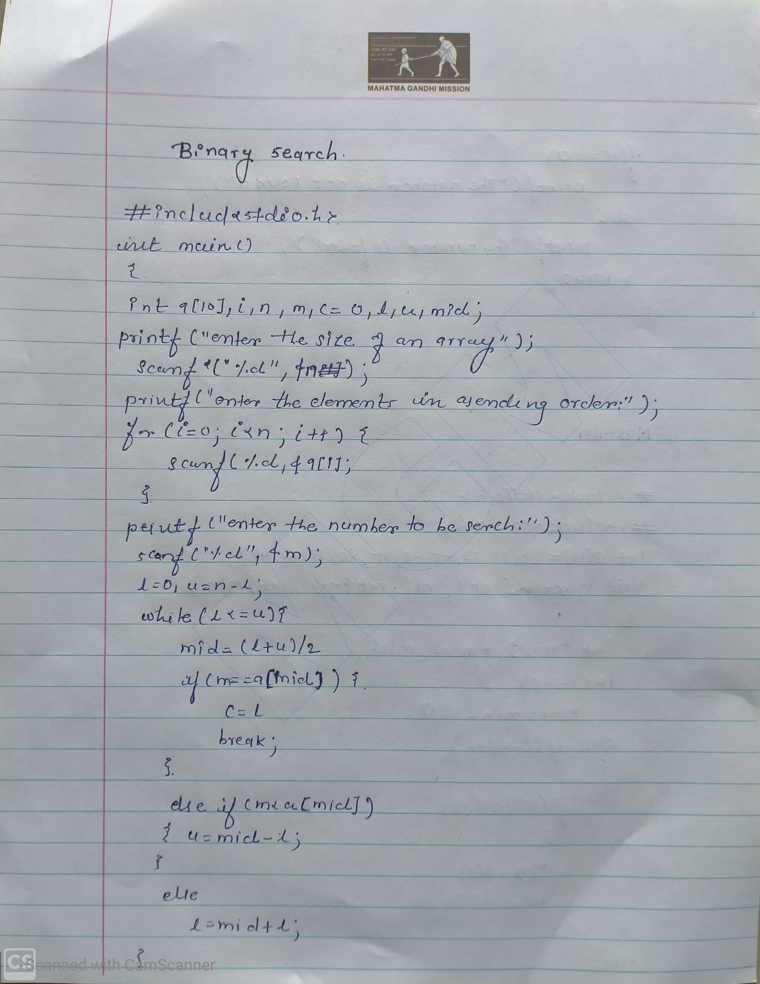

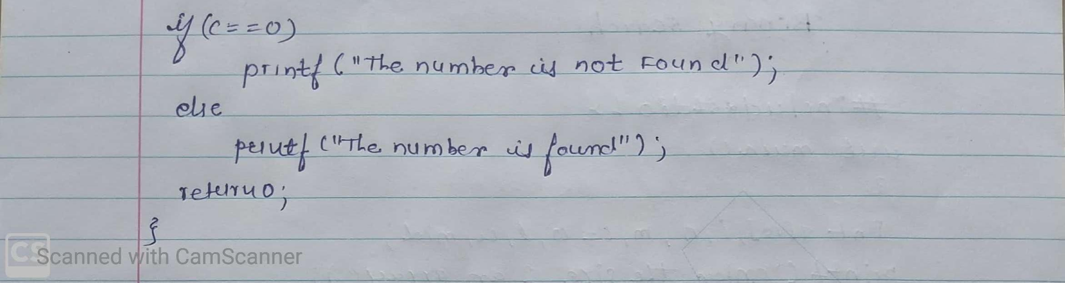

Screenshot of output

Conclusion

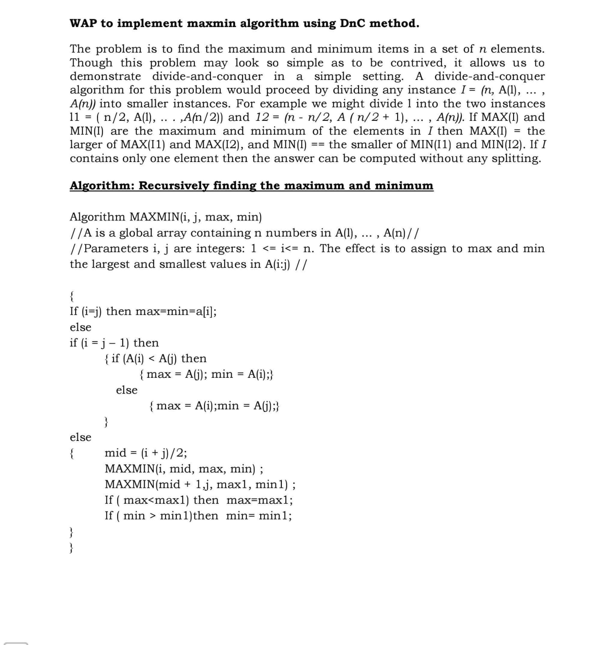 **Exercise No.: 04**

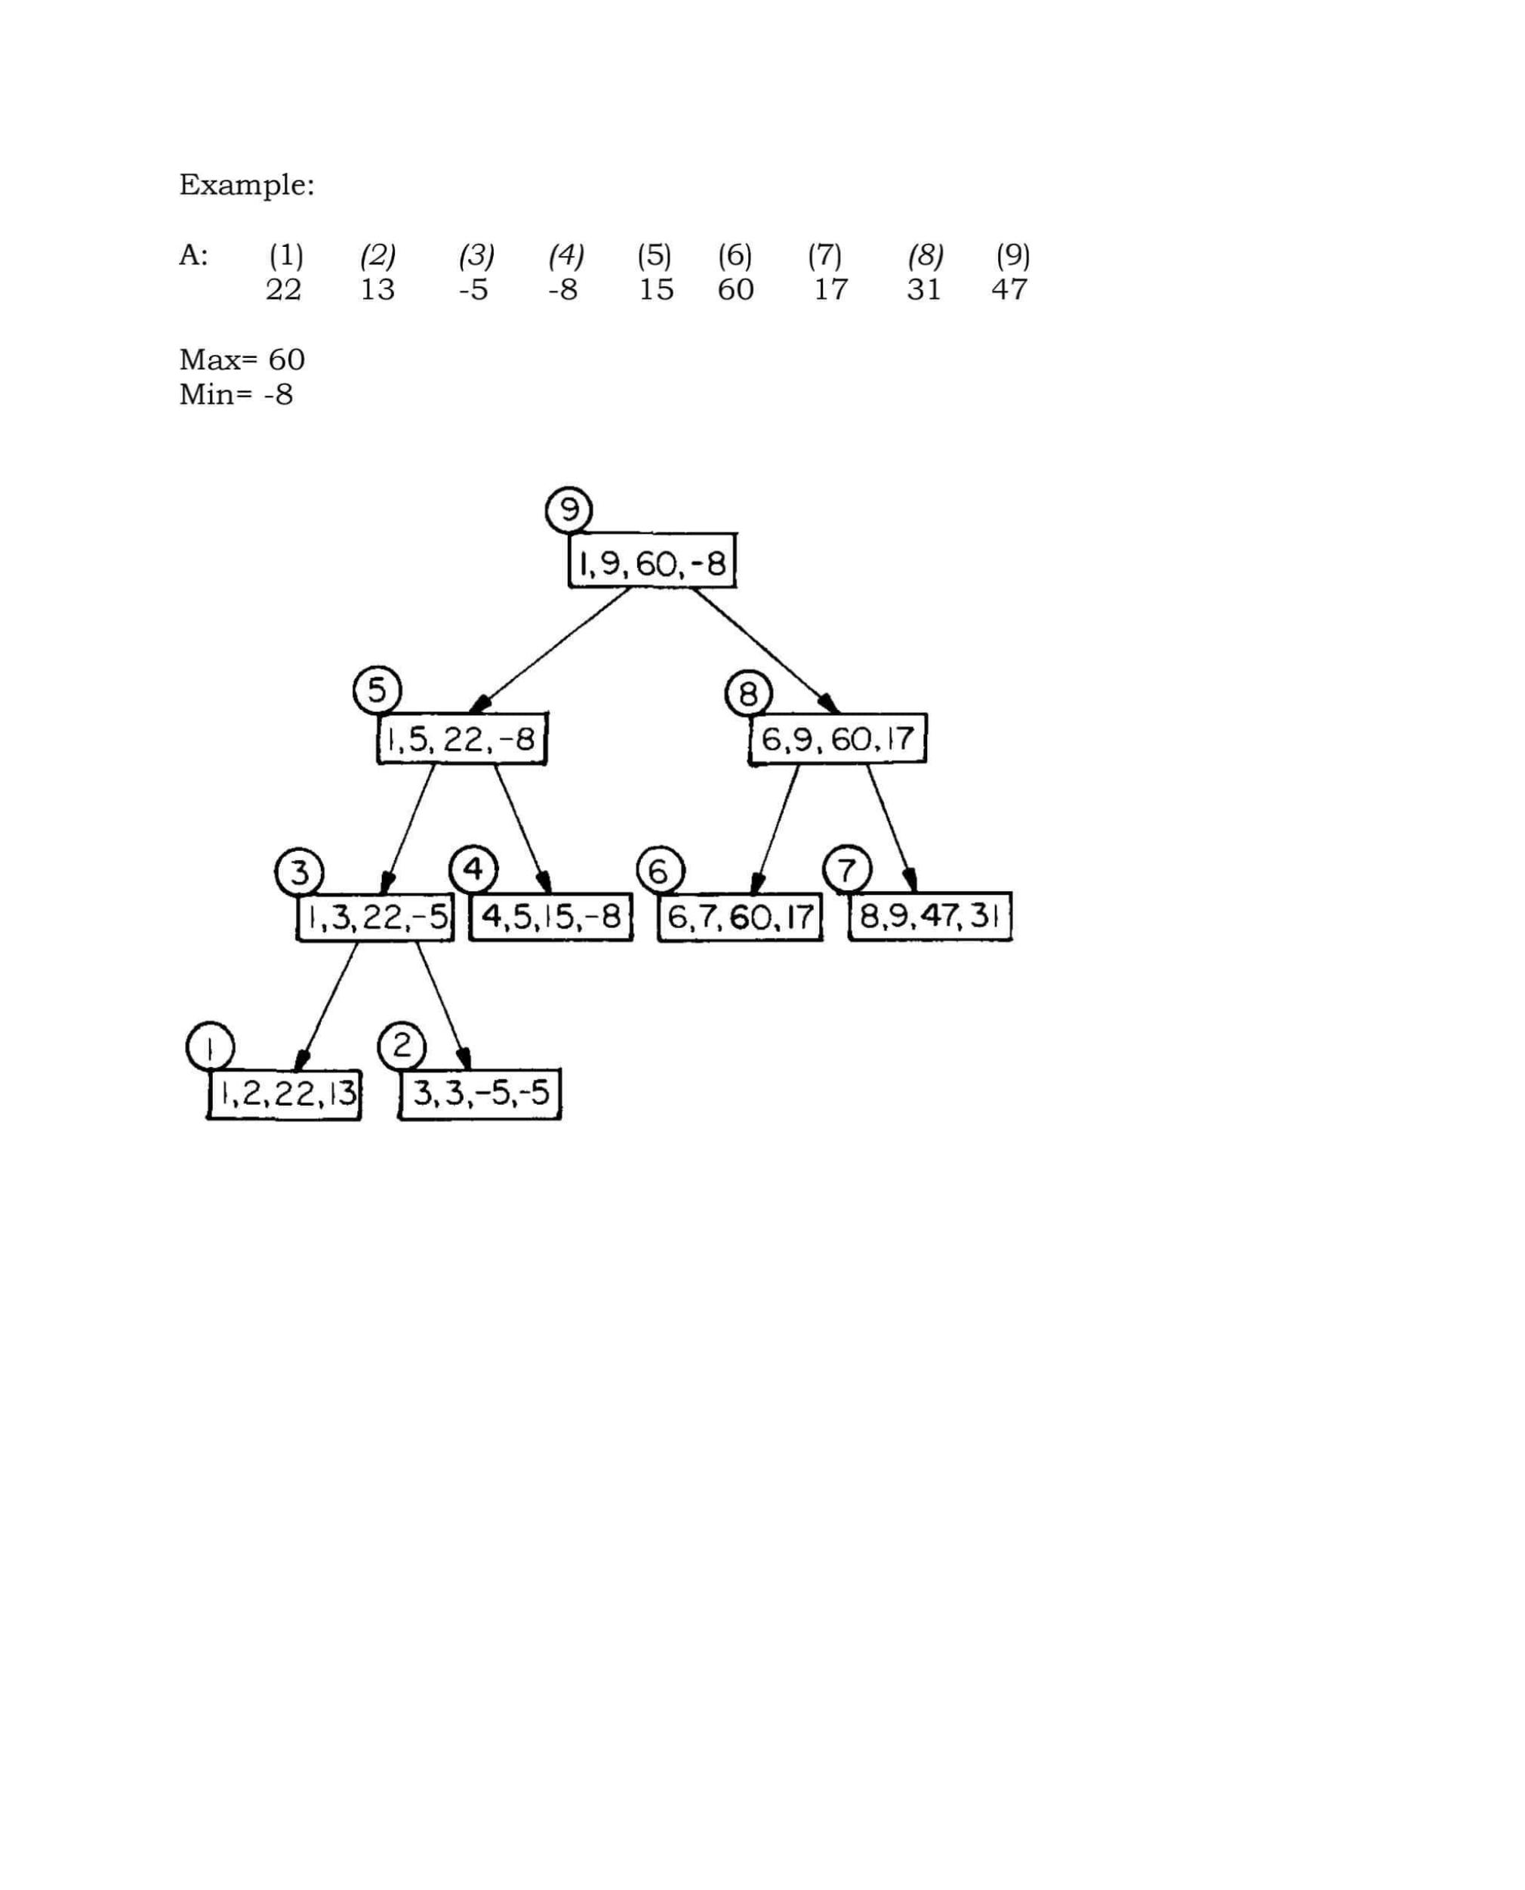

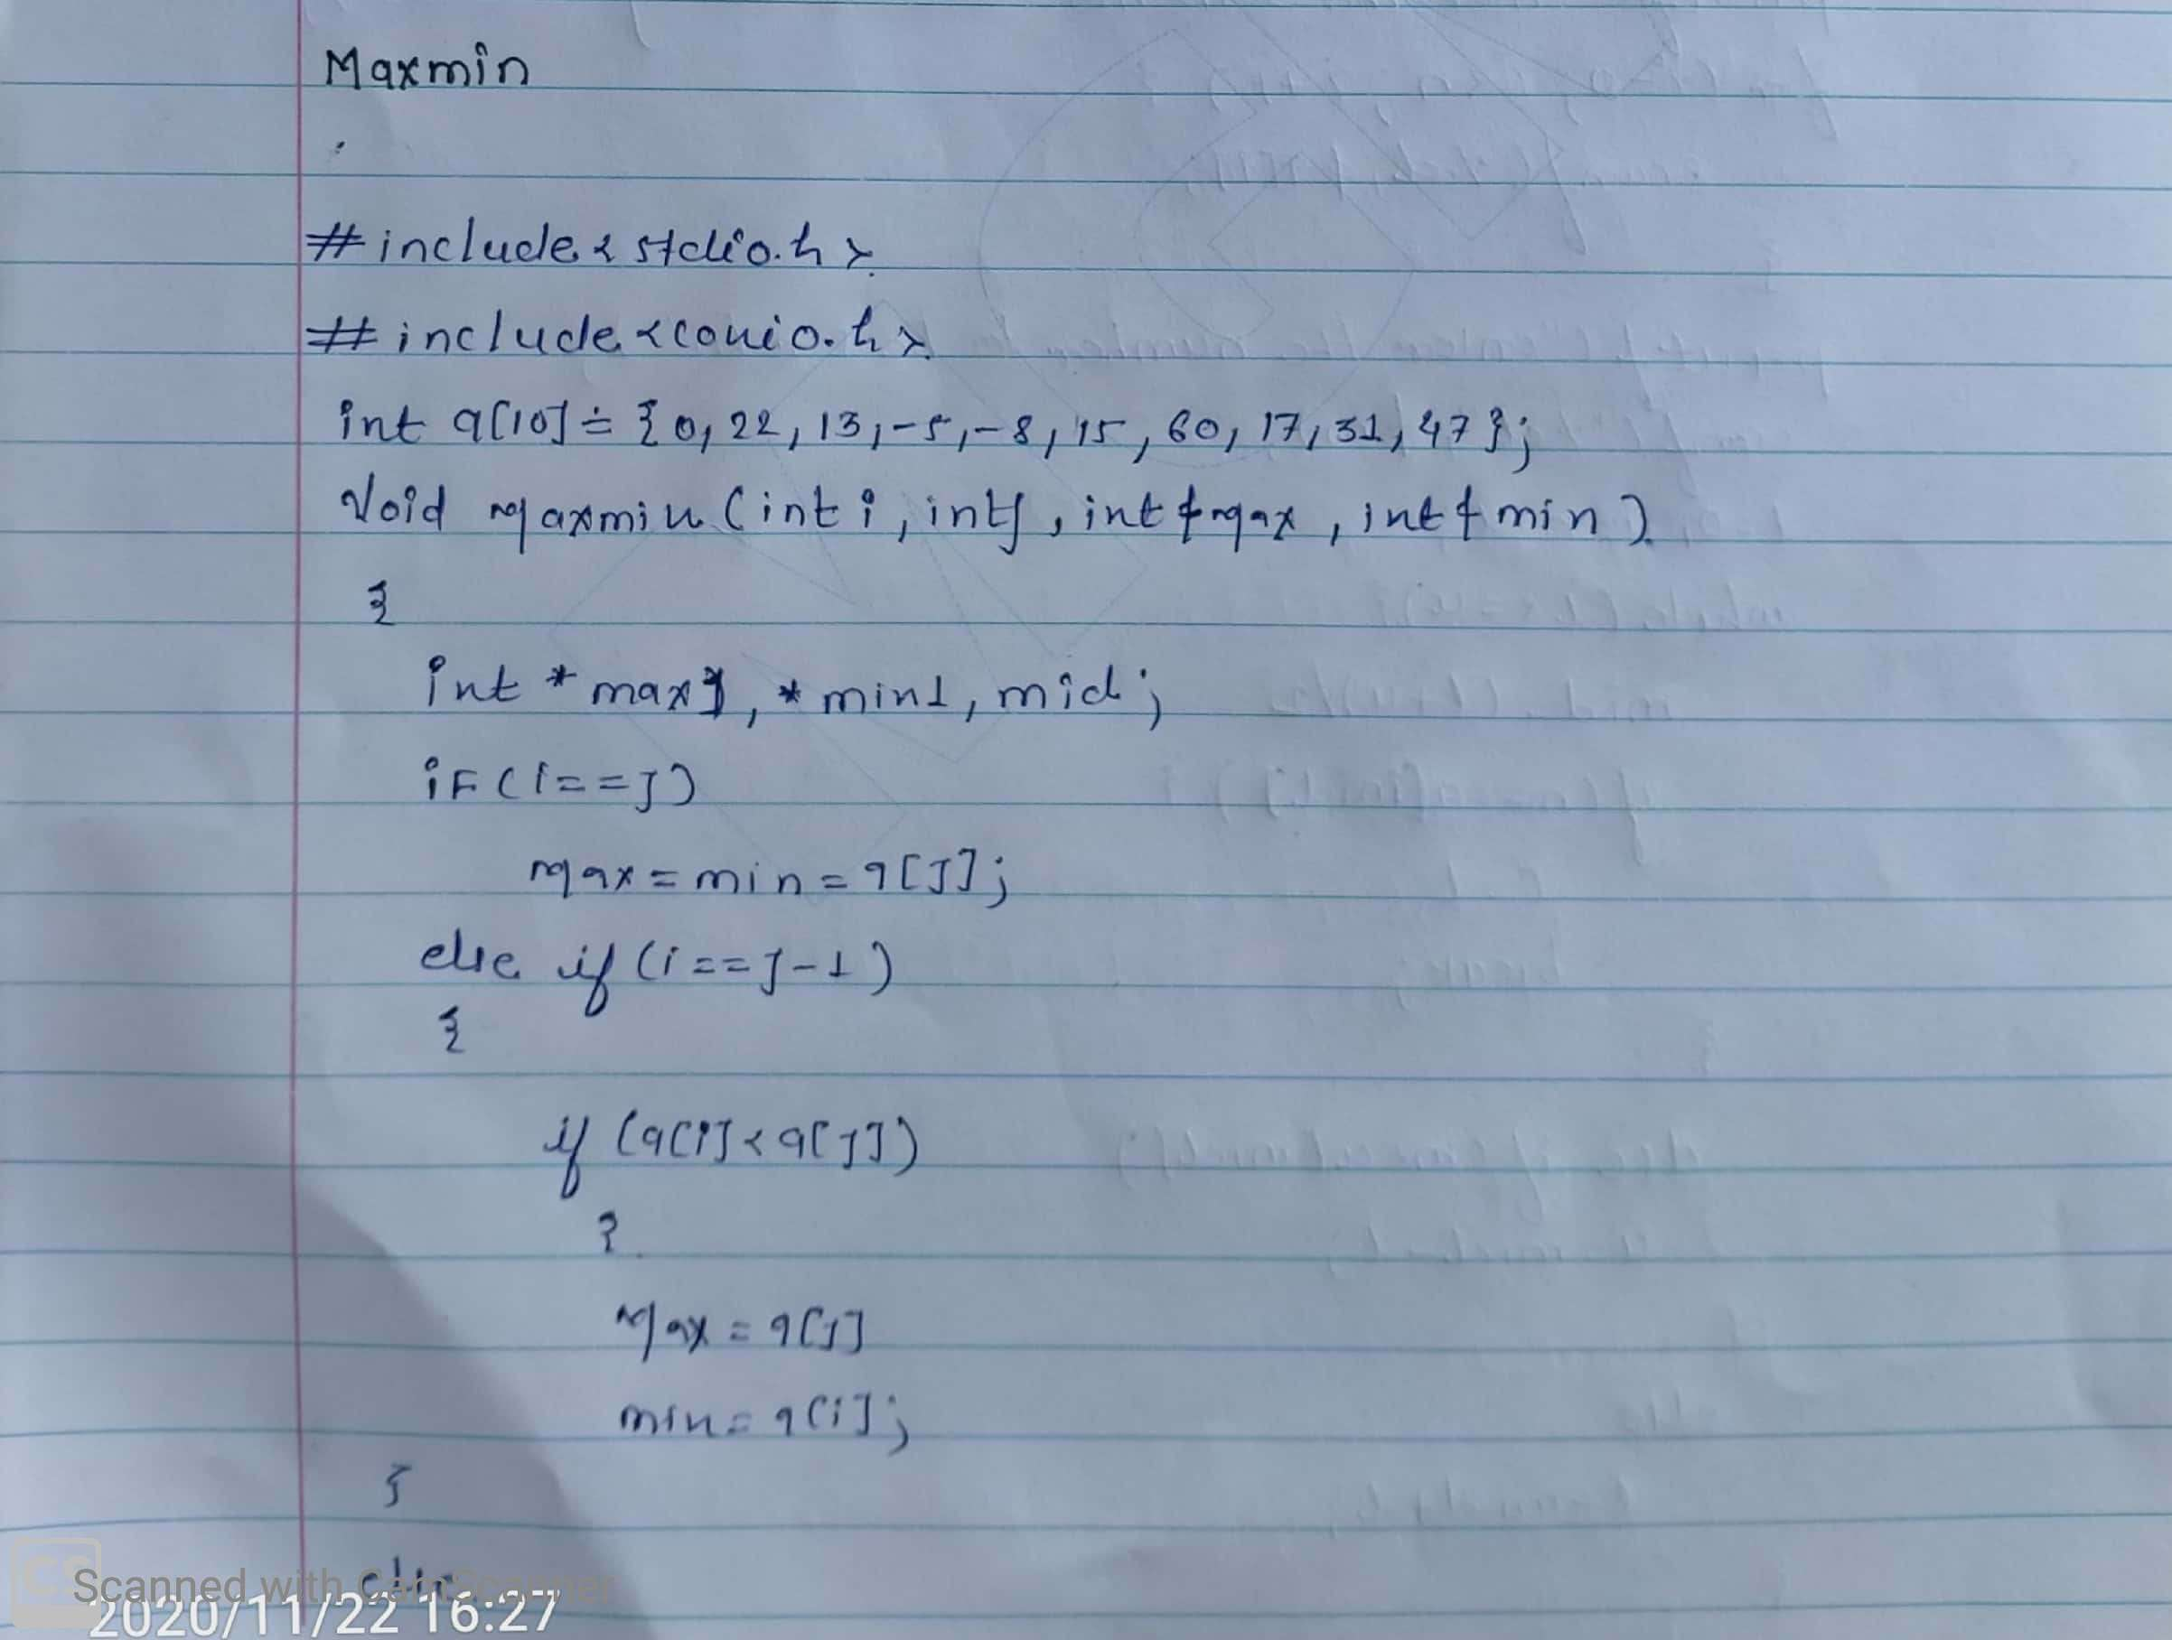

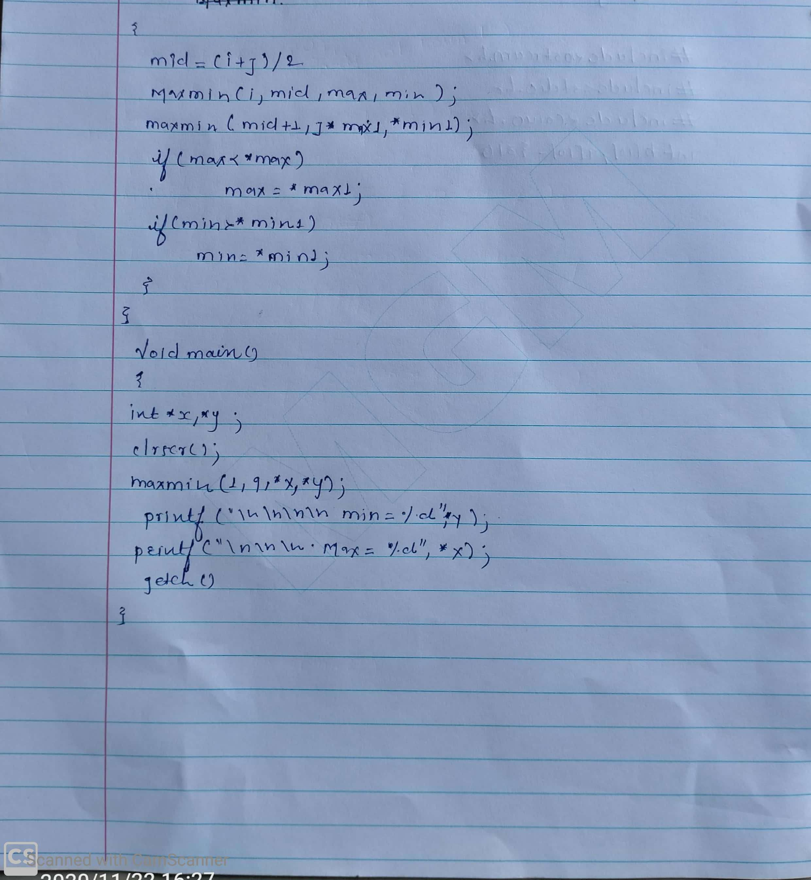

Screenshot of output

Conclusion

**Exercise:05**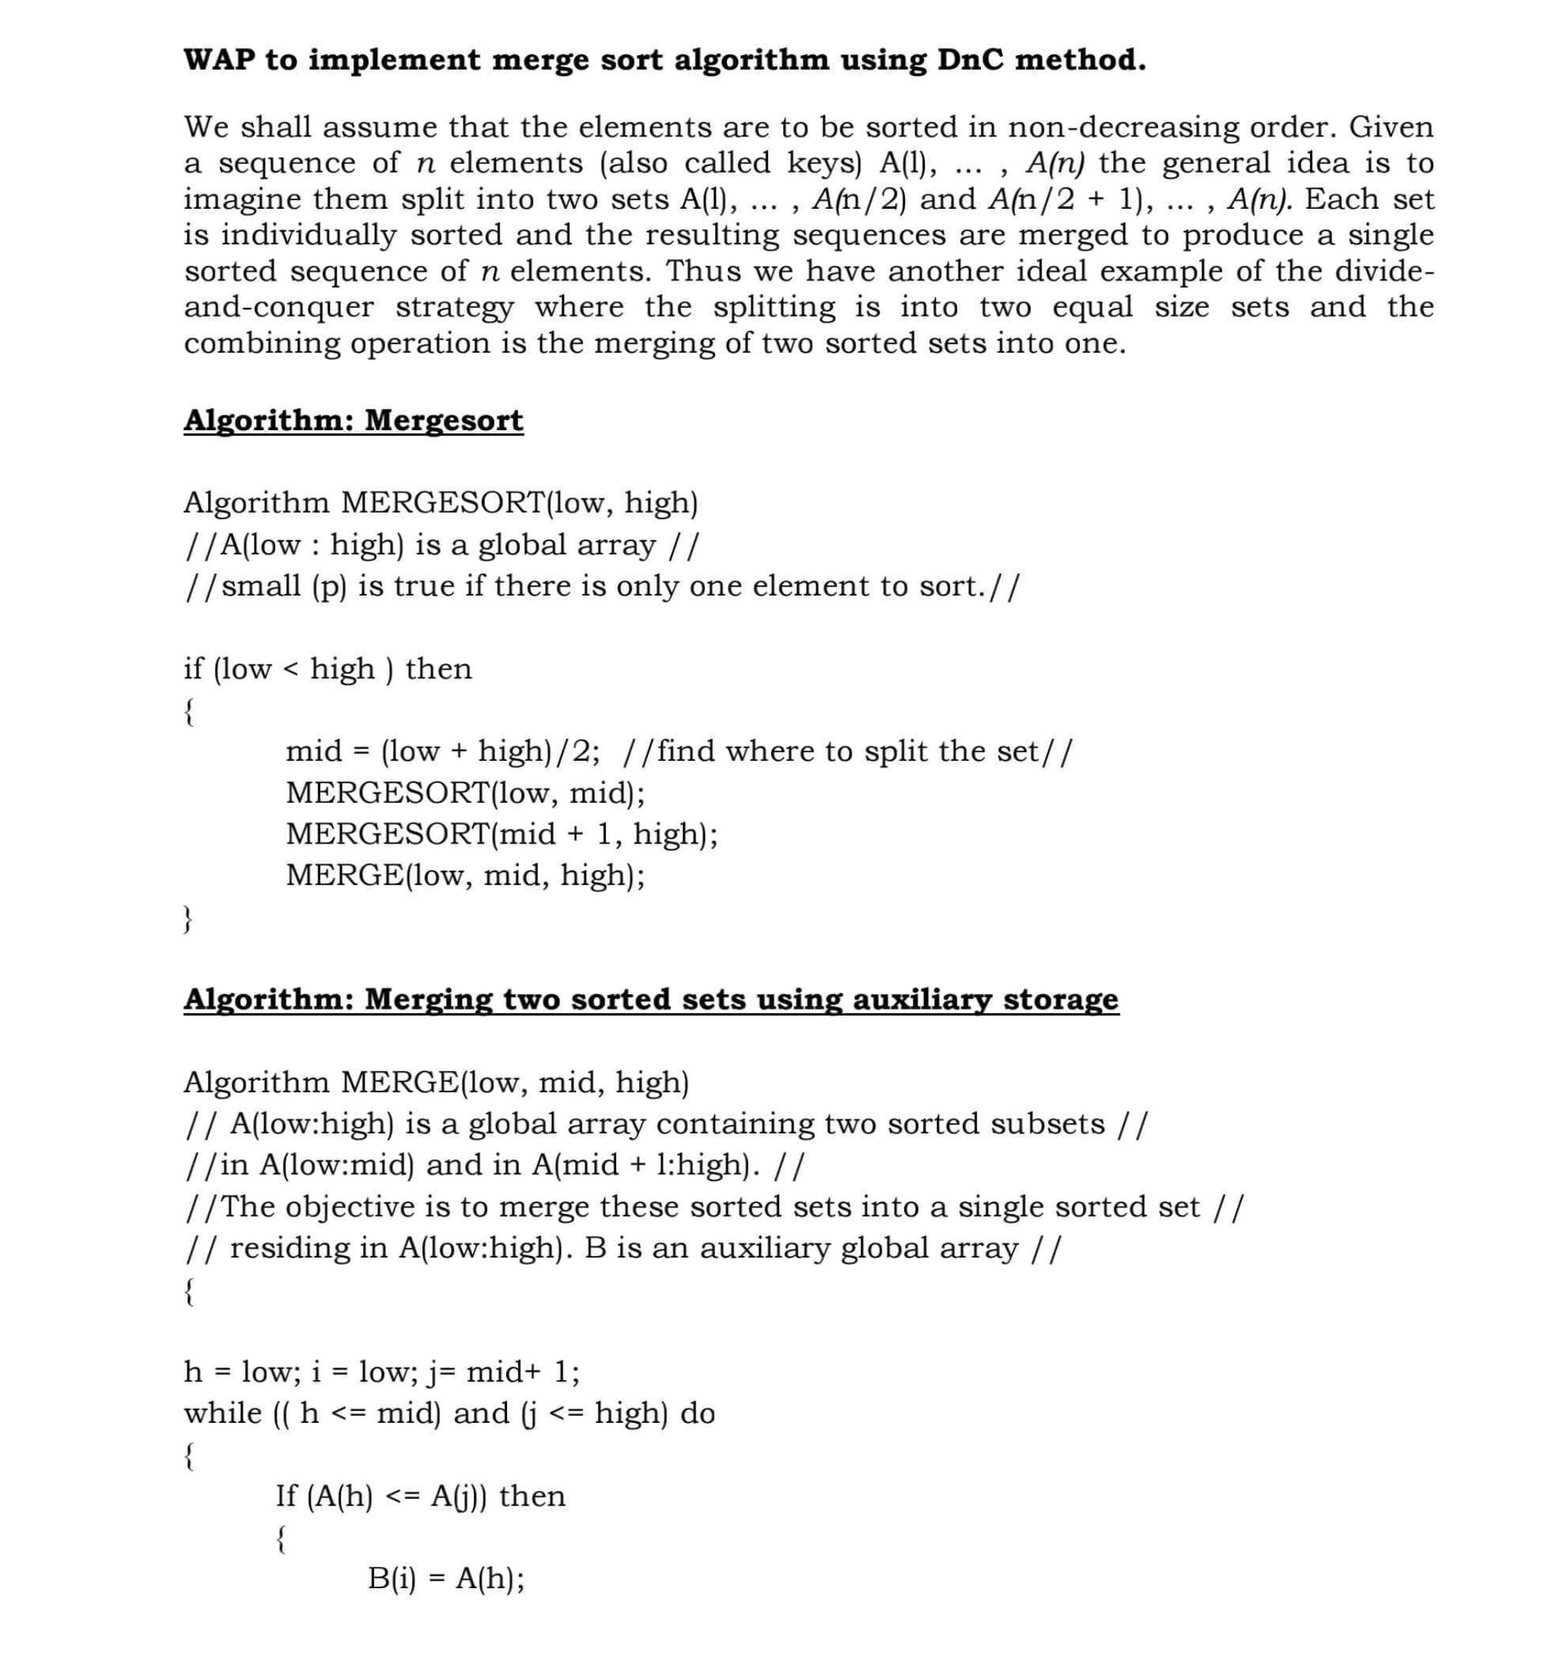

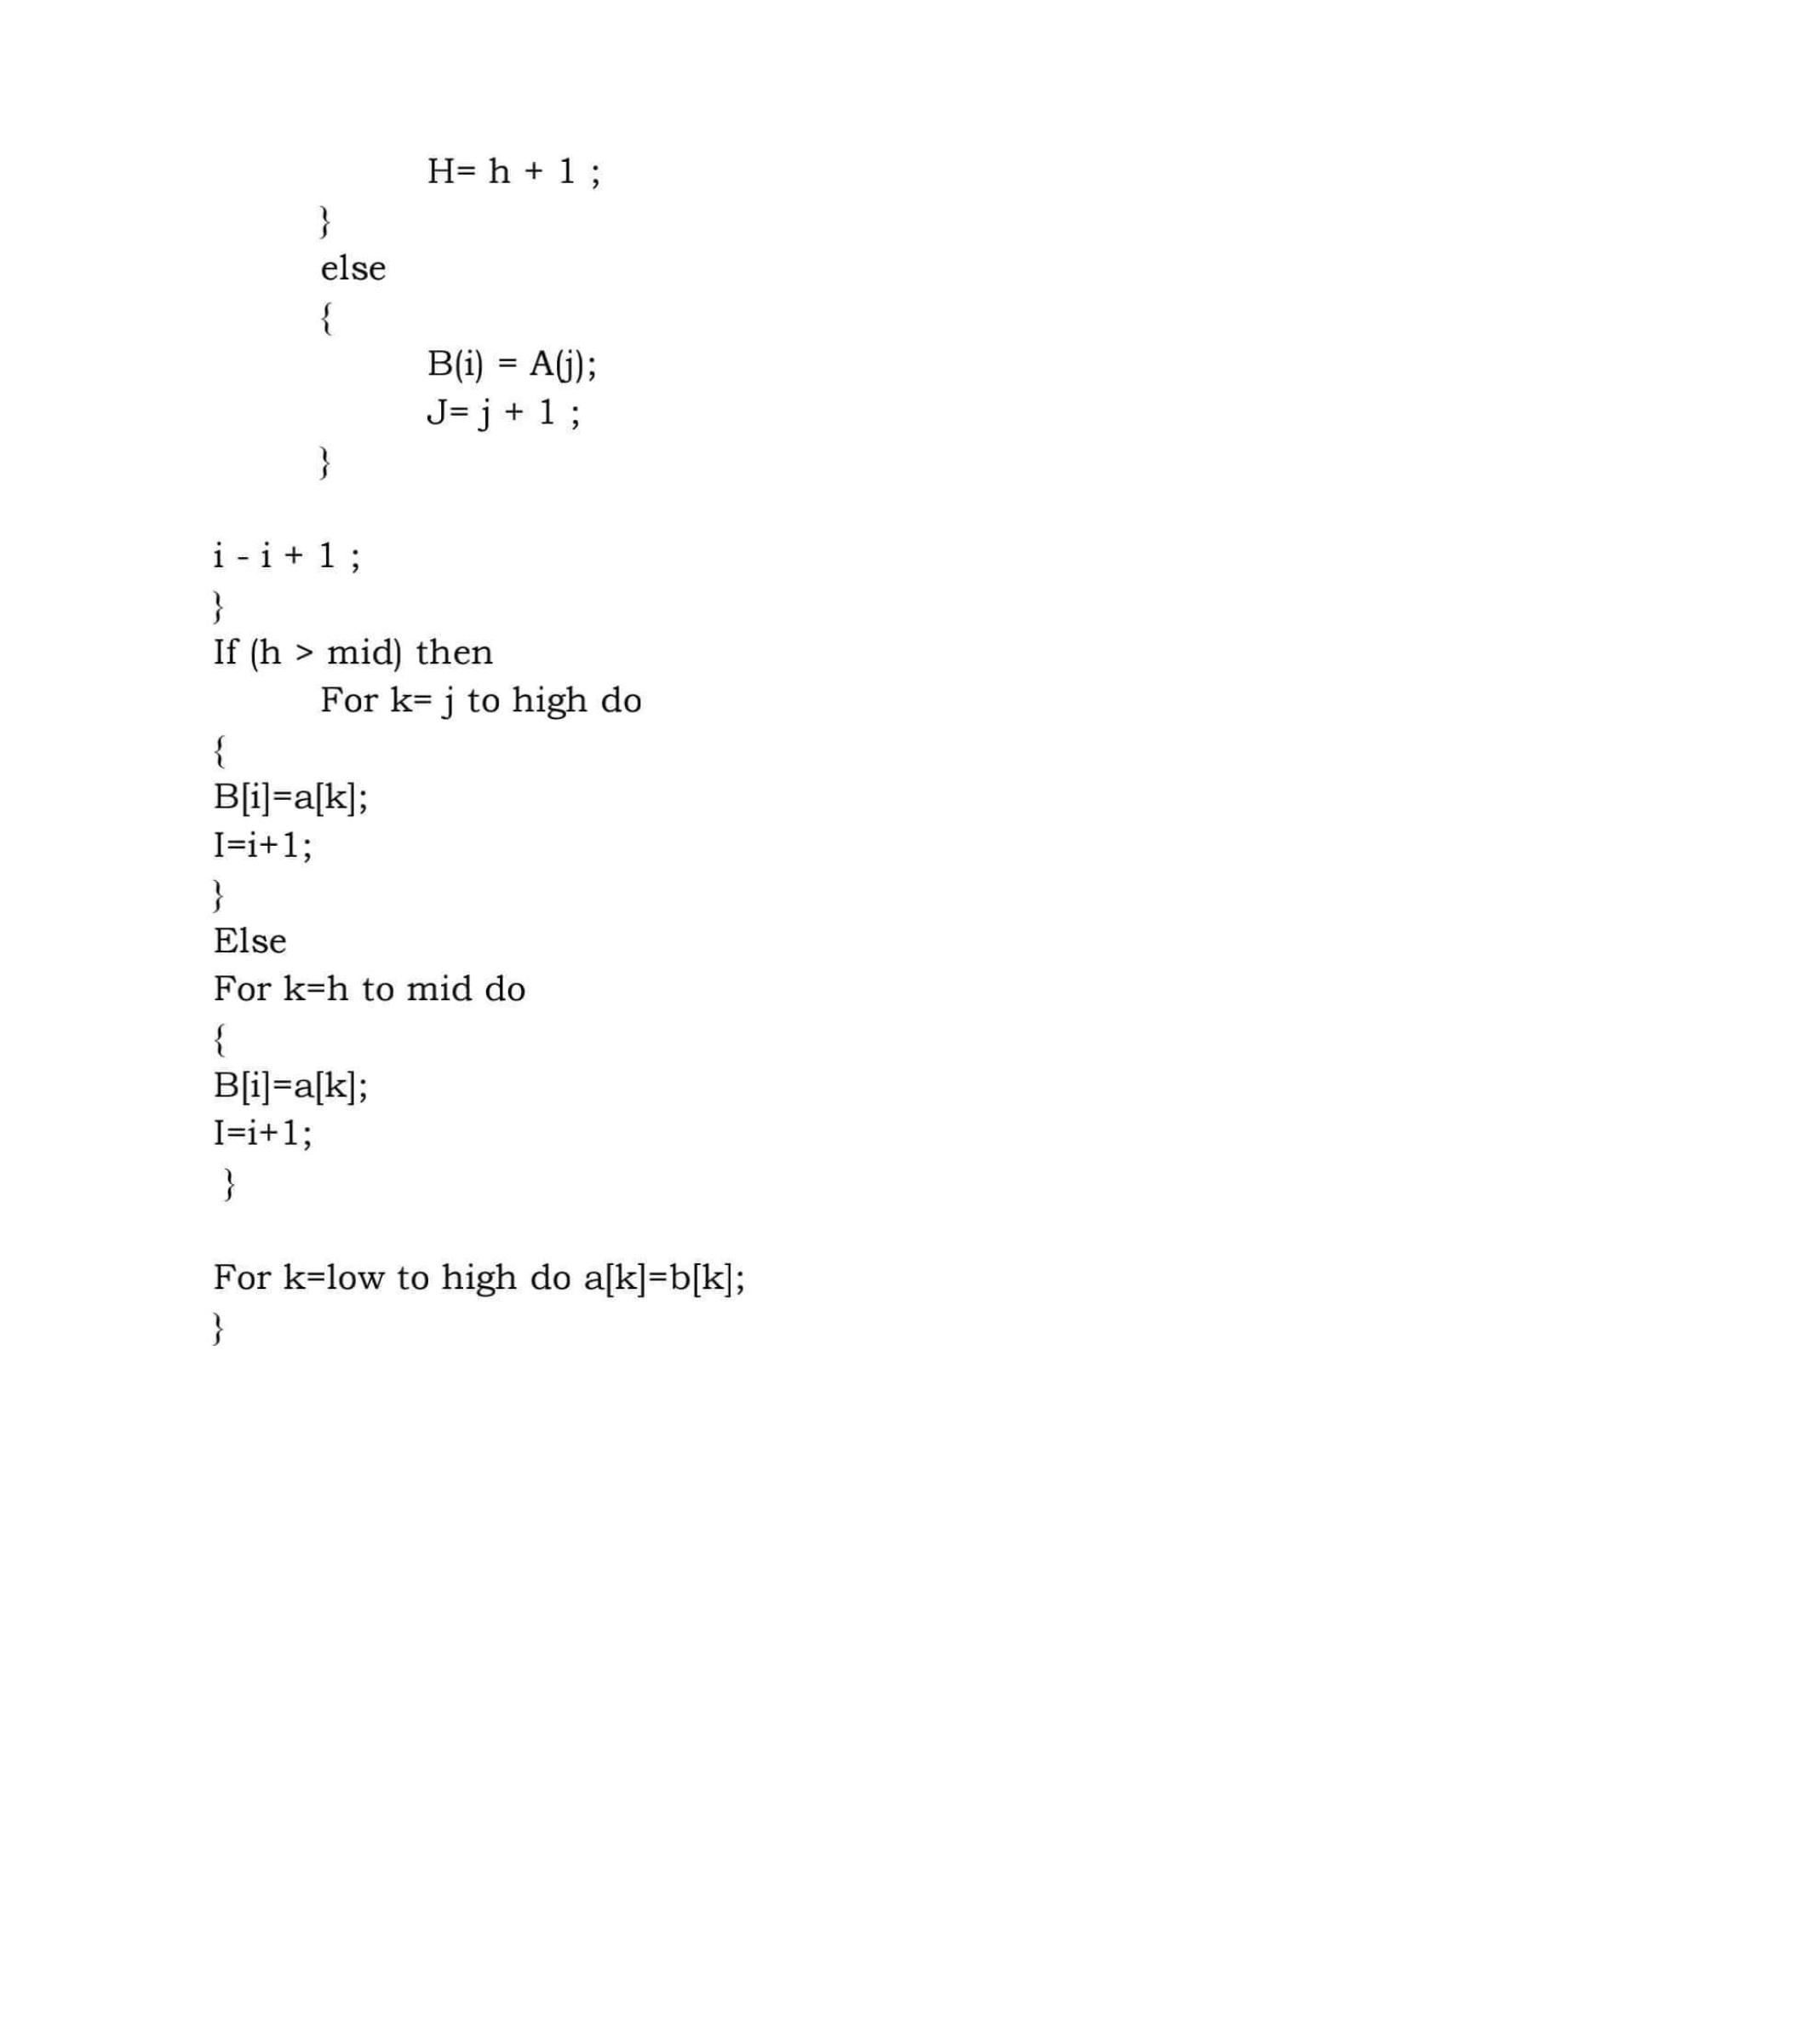

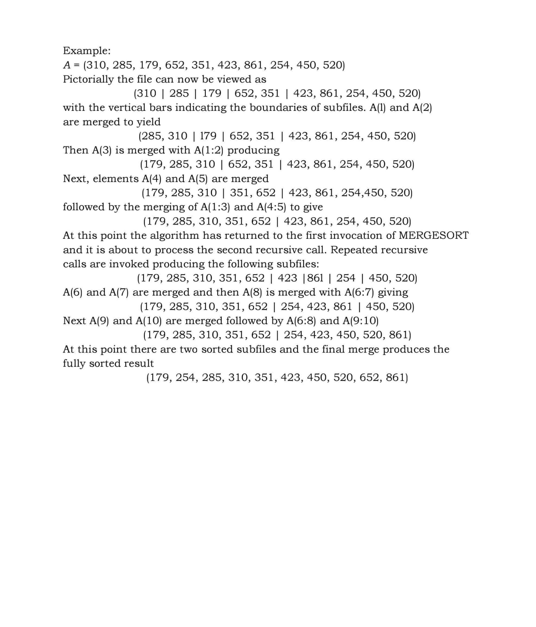

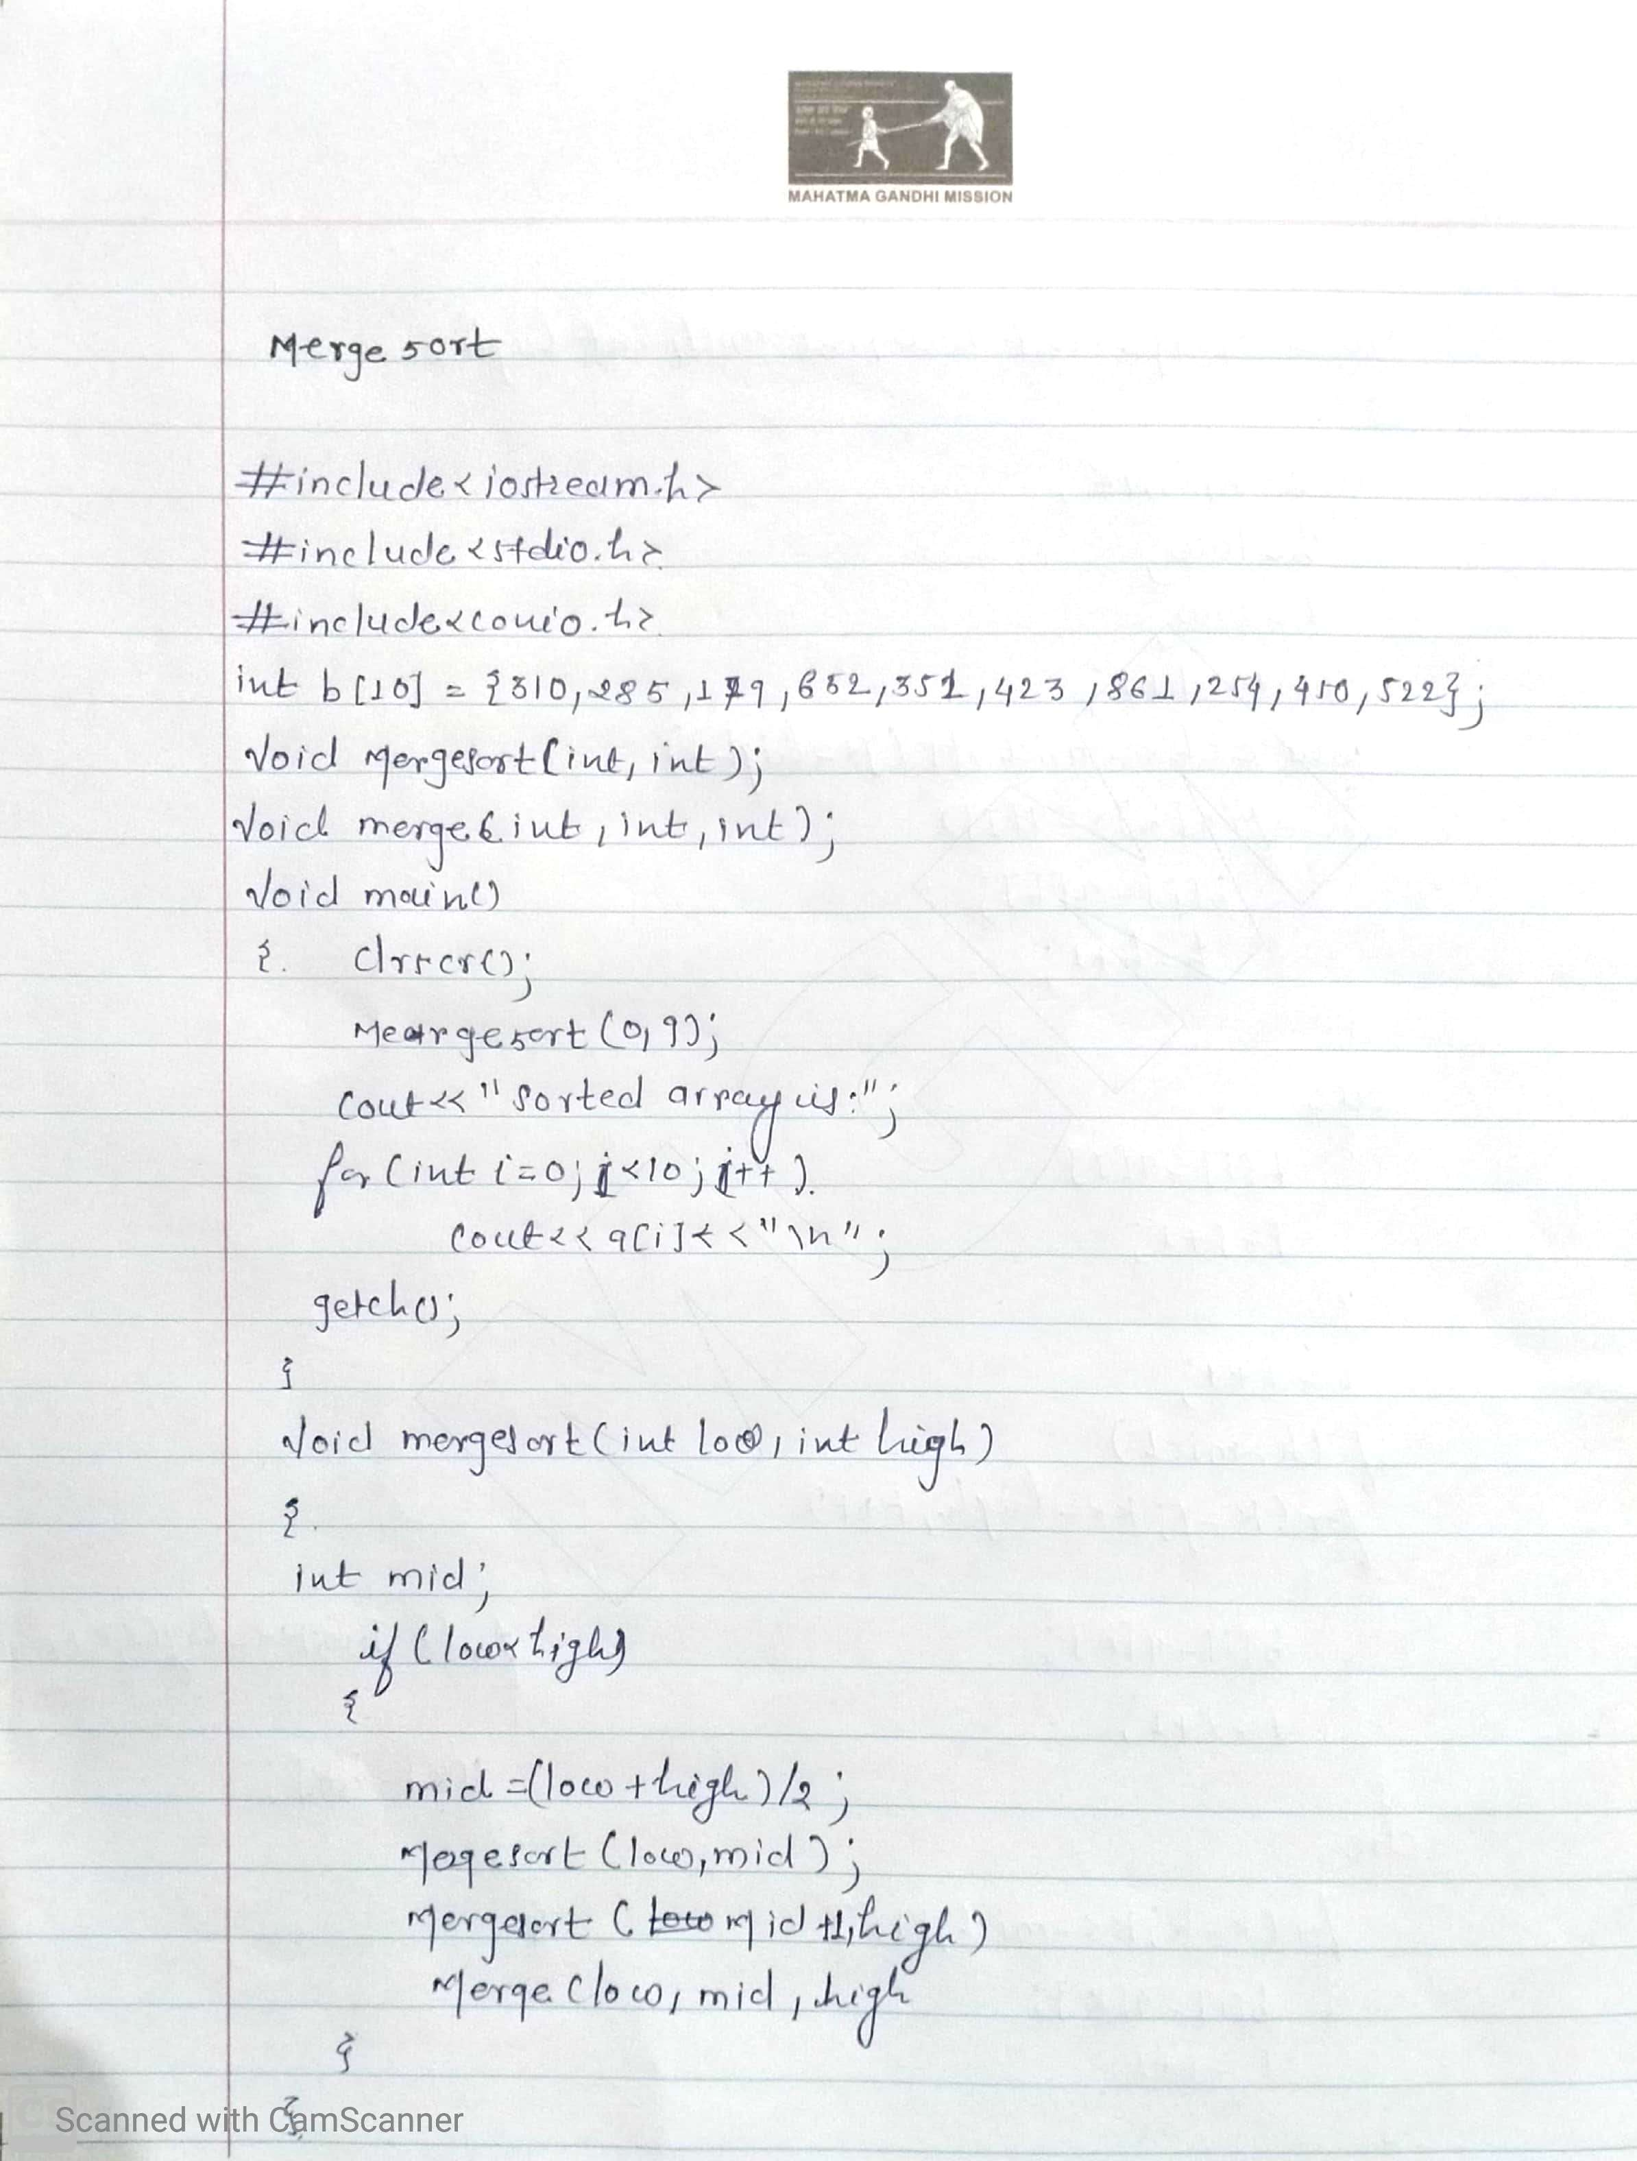

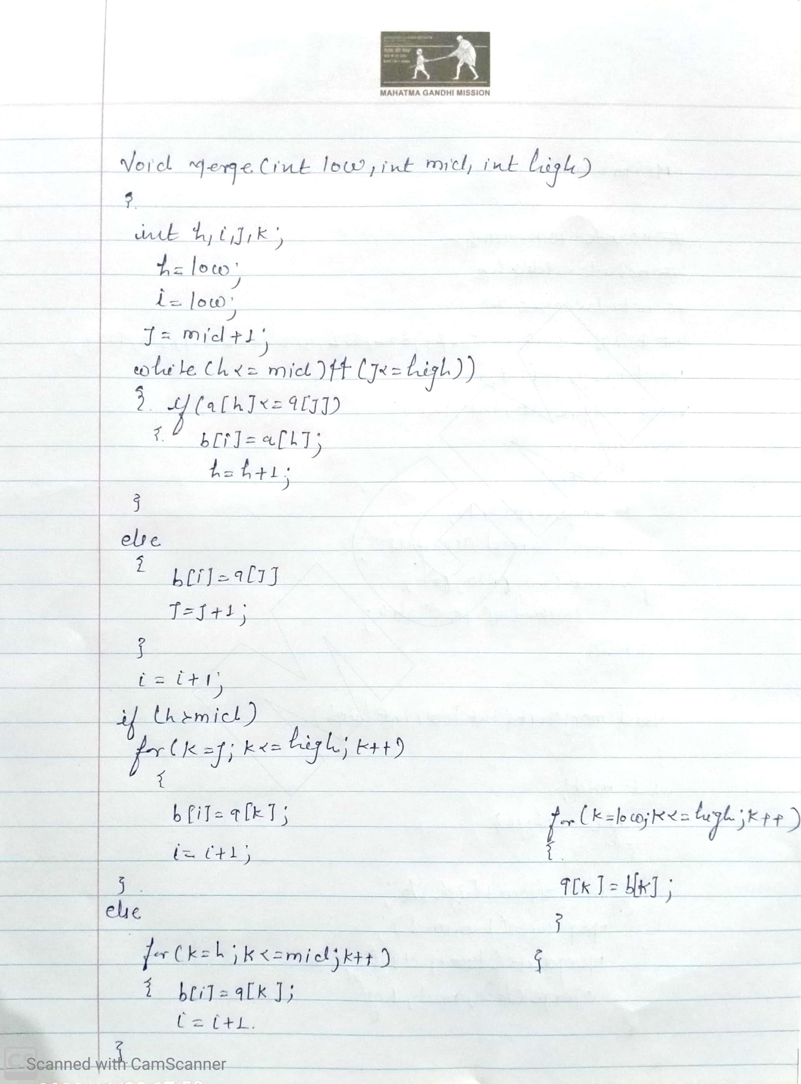

Screenshot of output

Conclusion

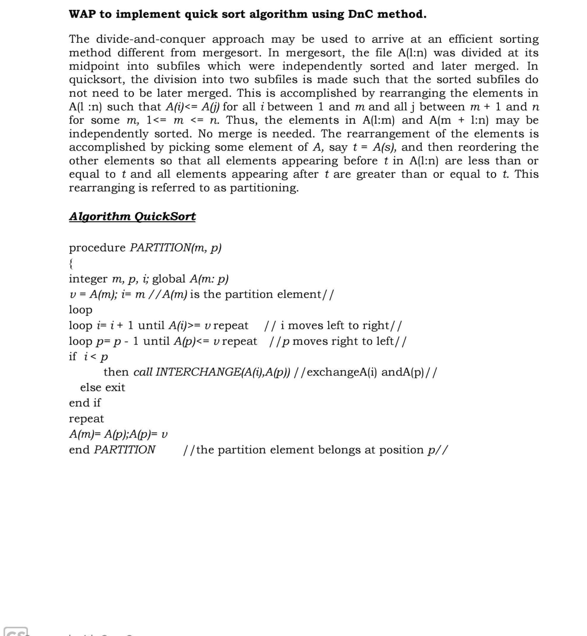 **Exercise No.: 06**

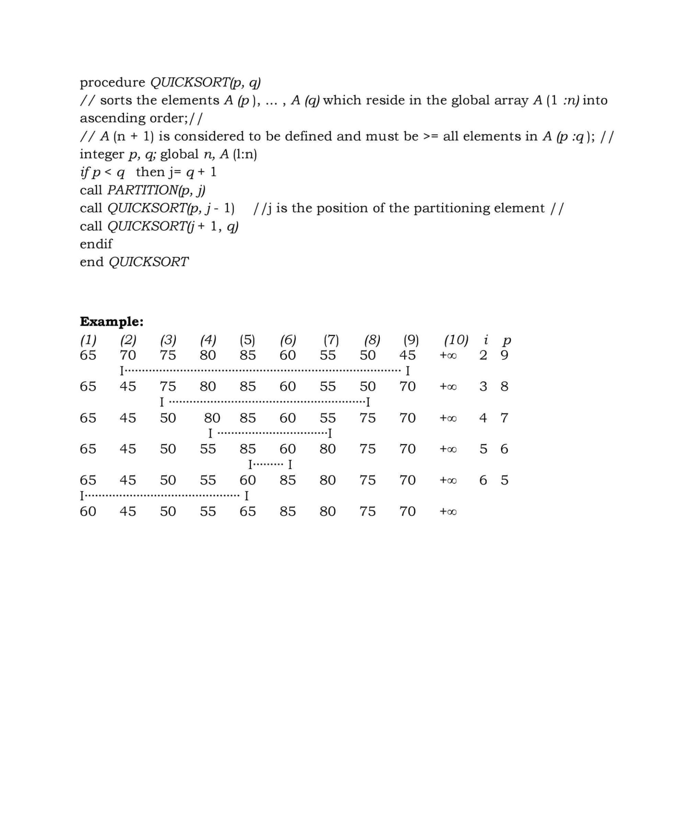



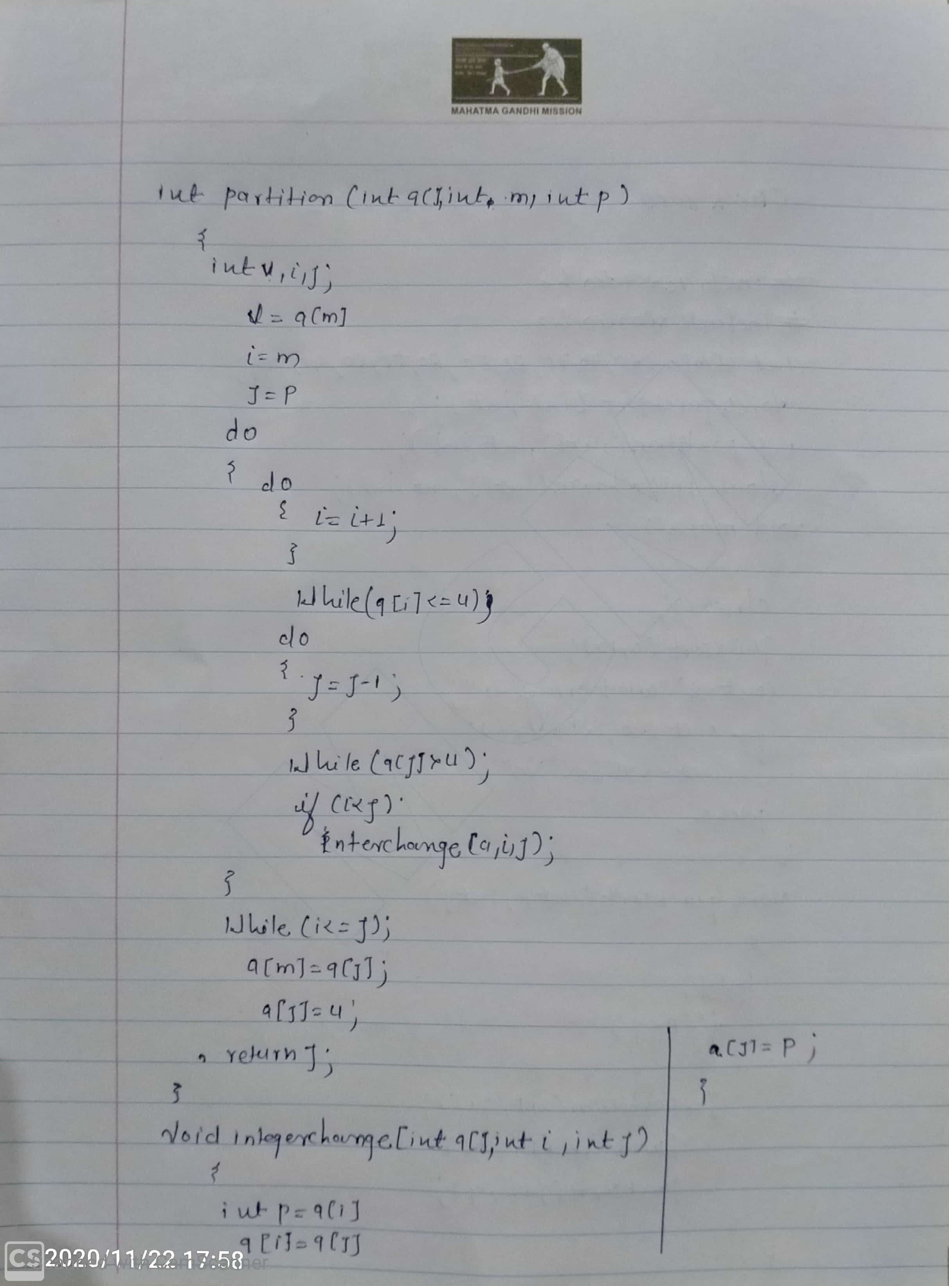

Screenshot of output

Conclusion

**Exercise:07**

